ICES Acoustic Data
Format Description

03 march 2022

International Council for the Exploration of the Sea
Conseil International pour l’Exploration de la Mer
H. C. Andersens Boulevard 44–46
DK-1553 Copenhagen V
Denmark
Telephone (+45) 33 38 67 00
Telefax (+45) 33 93 42 15
www.ices.dk
info@ices.dk
© 2022 International Council for the Exploration of the Sea

Contents
1 Version History 4
2 Data format 7
3 Data model 8
4 Vocabularies 9
5 Data formatting 10
5.1 Accepted formats 10
5.2 CSV format 10
5.3 XML format 10
6 Data submission 11

Version History
Version | Date | Author(s) | Description
1.0 | 28/09/2016 | AO, HP | Initial document published
1.0.1 | 14/10/2016 | HP | LogDistance unit is measured in nautical miles (nmi) and not meters (m)
1.0.2 | 26/10/2016 | HP | BiologyIndividualAge in the general format changed from mandatory to optional. Additional reporting status can be adjusted per survey
1.0.3 | 09/11/2016 | AO | DataType for Biotic CatchSubsampleWeight is amended.
1.1 | 16/11/2016 | HP | CatchSampleNumber added as an mandatory field to Biotic Catch and Biology as key
1.1.1 | 21/11/2016 | AO | Sample DataAcquisitionStoredDataFormat edited with valid codes
1.1.2 | 24/11/2016 | AO | AcousticDataType and Unit corrected with valid codes in the Acoustic.csv.xlsx format description
1.1.3 | 13/12/2016 | HP | Reference made to the acoustic metadata standard developed by WGFAST on which the format is based on.
1.2 | 15/12/2016 | HP | SampleSvTreshhold corrected, LogTime format extended with optional seconds, LogBottomDepth and added as optional field and LogValidity added as mandatory field. Biotic Depth data type changed from integer to decimal and IndividualLength changed from decimal to integer
1.3 | 11/1/2017 | HP | Catch record:  CatchSampleNumber removed.  CatchCategoryWeight removed.  CatchSpeciesCategory changes to mandatory sequential integer.  CatchSpeciesTotalWeight renamed to CatchSpeciesCategoryWeight.  CatchSpeciesTotalNumber renamed to CatchSpeciesCategoryNumber.  Biology record:  CatchSampleNumber changed to CatchSpeciesCategory.  BiologyIndividualLength renamed to BiologyLengthClass.
1.3.1 | 15/01/2018 | AO | Multiple surveys are allowed in one cruise
1.3.2 | 11/09/2018 | AO | Changed contact address from accessions@ices.dk to acoustic@ices.dk; moved version history to the end of the document; added TXT as the valid file format
1.3.3 | 03/10/2018 | AO | XML offline package updated
1.3.4 | 12/11/2018 | AO | ChannelDEpthUpper/Lower data type change from int to floating point
1.3.5 | 06/02/2019 | MA | XSD Schemas are updated to prevent an empty value for the Vocabularies
1.4 | 15/03/2019 | HP & AV | In Acoustic format:  -EchoType Record created. Fields: EchoTypeStratum, EchoTypeSpeciesCode, EchoTypeSpeciesCategory, EchoTypeComments and EchoTypeID.  -In Data Record added EchoTypeID Field.  -Created two examples for Acoustic format CSV: with SaCategory, with no changes, and with Echotype (with all additions previously mentioned)  In Biotic format:  -In Haul Record, added HaulStratum Field.  -Added HaulStratum field to the CSV format example.  In this document:  -Moved Version History section to the beginning of the document.  -Edited Section 3. Data Model.
1.4.1 | 09/11/2020 | AV | Added examples for UTF-8 coding in 5.1
1.5 | 03/03/2022 | HP | In Acoustic format:  Added optional LogLatitude2, LogLongitude2 and LogOrigin2 used to specify end position for the given log to accommodate acoustic data from drones and the like.  In Biotic format:  Added optional BiologyIndividualGrowthRings to accommodate the needs to give the number of growth rings instead or in addition to the age of an individual.  XSD version:  Added version attribute to xsd’s

AO: Anna Osypchuk
HP: Hjalte Parner
MA: Mehdi Abbasi
AV: Adriana Villamor

Data format
The acoustic data format consists of two parts – an Acoustic and a Biotic part – which are described by a number of documents and example files as below:
• Acoustic
• Acoustic.csv – Acoustic CSV data example
• Acoustic.csv.xls – Acoustic CSV data format description
• Acoustic.xml – Acoustic XML data example
• Acoustic.xsd – XML Schema describing the Acoustic XML structure
• Acoustic.sch – XML Schematron describing the Acoustic XML validation rules.
• Biotic
• Biotic.csv – Biotic CSV data example
• Biotic.csv.xls – Biotic CSV data format description
• Biotic.xml – Biotic XML data example
• Biotic.xsd – XML Schema describing the Biotic XML structure
• Biotic.sch – XML Schematron describing the Biotic XML validation rules.

The acoustic part of the format is based on the SISP 4 – A metadata convention for processed acoustic data from active acoustic systems developed by the ICES Working Group on Fisheries Acoustics, Science and Technology (WGFAST), while the biotic part of the format is based on the ICES Database of Trawl Surveys (DATRAS).
Please note that the acoustic metadata standard has a wider scope than the acoustic trawl surveys and as such contains fields that are relevant beyond this purpose. The spatial (x, y and z) and temporal (t) coverage in the metadata standard is defined using the Dublin core; for practical purposes this has been implemented as point based in the applied format. In addition, the fields sample Sv threshold, data Sa category and value have been added to the format.
Where possible, a direct reference between the acoustic format field and the corresponding field in the acoustic metadata standard is provided.

Data model
ICES Acoustic data can be described by the Data model below (Figure 1.)
The Acoustic part of the data format consists of six record types: the five metadata record types Instrument, Calibration, Data Acquisition, Data Processing, and Cruise; and one data record type Data, which is the combination of Log, Sample and Data entities in the data model below. Metadata record EchoType in the model is optional, and is used only if the Data record is reported with EchoTypes. When the SaCategory is used for data reporting, the record EchoType should be excluded from the reporting format.
The Biotic part of the data format consists of four record types: one metadata record Cruise; and three data record types Haul, Catch, and Biology.
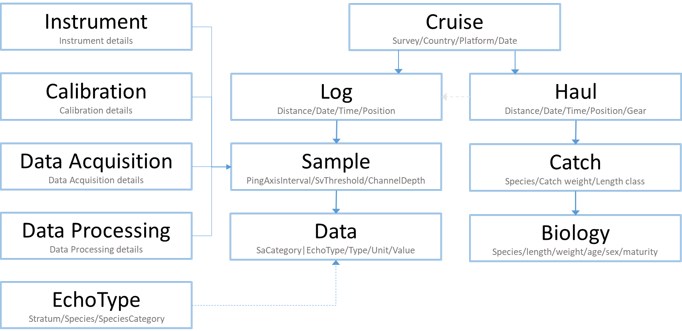
Figure 1. Data model.

Vocabularies
Both the acoustic and the biotic parts of the format contain fields that rely on controlled vocabularies. The vocabularies are accessible via the ICES vocabulary server http://vocab.ices.dk. If a given code does not exist, or if code relations are missing in the related vocabulary lists, an error will be raised during validation. A new vocabulary item and an associated code, or a code relation can be requested via acoustic@ices.dk.

Data formatting

Accepted formats
Data from acoustic surveys can be submitted using either comma-separated values (CSV) or eXtensible Markup Language (XML) formats depending on the submitter’s preference. The CSV format is more condensed and easy-to-read, while the XML format is more self-descriptive and transparent. Naturally, a .csv extension would be assigned to the comma-separated files, but as some of the field values can be automatically altered by Excel, use of the .txt extension for the comma-separated files is also allowed. XML format should be submitted with .xml file extension.
The Acoustic and Biotic parts of the format should be reported as two separate files and only contain data from one cruise each. Cruise record in both files should be the same. If the same cruise was used for 2 different surveys, both surveys should be reported in the CruiseSurvey field, separated by tilde (“~”).
The use of UTF-8 character-coding format is required for submissions. This can easily be done in Notepad or Notepad++. In Notepad, open the file, then “Save as” and in encoding box select “UTF-8” option before saving the file. In Notepad++ after opening the file, select “Encoding” and then select “Convert to UTF-8” before saving the file.
It is important that the submitted files are created using the following rules:
- Decimal numbers should be separated with decimal points, not commas.
- Text fields in any format may not contain the special characters “,” ”;” “<“ ”>“ or ”/“ as they would cause problems during data validation.
- Fields with no data available should not be reported with “-9”. Leave the fields empty instead. Reporting “-9” is allowed only when it is an actual value of the numeric field, i.e. Longitude.
- CSV files should contain only one record per line.
- CSV fields within a given record should be separated with commas.

CSV format
The attached Acoustic.csv.xlsx and Biotic.csv.xlsx files provide detailed descriptions of the CSV format for the Acoustic and the Biotic parts of the data format respectively, while the files Acoustic.csv and Biotic.csv show the actual example data.
As seen from the descriptions, each record type should have only one header line and at least one associated record. Typically, a data file will contain one header and one related record for each of the metadata record types, while a data record type will have one header followed by any number of the data records. Reporting format can be customized by the submitters, where only mandatory fields and used optional fields need to be included, i.e., optional fields not in use can be left out of the data file together with their headers.

XML format
Acoustic.xsd and Biotic.xsd describe the XML schema structure for the respective parts of the format, while Acoustic.sch and Biotic.sch files describe the XML validation rules used in the XML data validation.
The provided XML schema and schematron enlist all the implemented validation rules in a transparent and easy-to-follow way.
As such, they can potentially be used for data validation by the data originators before submitting data to ICES.

Data submission
Acoustic and Biotic data within the Acoustic database can be managed through the Acoustic portal at http://acoustic.ices.dk.
In the submission process, a submitted XML file will be validated directly against the XML schema and schematron rules, while a submitted comma-separated file will be converted on the fly into the XML format to allow validation.
Files that successfully pass the data validation can be uploaded to the Acoustic Database. If validation for some reason fails and errors are found during validation, a detailed validation error report will be produced, so that the submitter can correct the errors before resubmitting. All errors need to be fixed before the data can be uploaded into the Acoustic database and downloaded as StoX files.
Acoustic and Biotic data should be submitted cruise wise e.g. one cruise at a time, and it is recommended to use the local cruise id e.g. LocalCruiseID in the naming of the data files. The recommended naming convention for the local cruise id is to use the following template [Datatype]_[PlatformCode][Year][CruiseNo] and name the files accordingly.
e.g.
Acoustic_26D1201601.csv or Acoustic_26D1201601.xml
Biotic_26D1201601.csv or Biotic_26D1201601.xml
When more details become available for the cruise, or there were some data revisions, data submitters are encouraged to update their data in the Acoustic database by re-submitting the respective Acoustic or Biotic files. When the replacement file is successfully validated, it is important to delete the previous submission from the Acoustic database via the http://acoustic.ices.dk/submissions before re-uploading the file. If any changes were made in the Cruise record, both Biotic and Acoustic files need to be deleted and re-uploaded.

http://bit.ly/2gfZrAa
http://dublincore.org/workshops/dc4/dc_coverage.html

